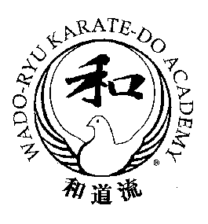

WADO-RYU KARATE-DO ACADEMY
INSTRUCTORS’ COURSE
For all Wado Academy 1st Kyu and Dan graded members (whether instructing or not).

The Acting Chief Instructor of the Wado-Ryu Karate-Do Academy, Arthur Meek 8th Dan Renshi would like to invite all 1st Kyu and Dan Grade members to an Academy Instructors’ Course.

The aim of these courses is to maintain the very high standards of Wado-Ryu karate that Academy members achieve. It is therefore important that all Wado Academy instructors attend.

Please bring your up-to-date Wado Academy Passport for endorsement. If membership is out of date, renewal must be paid before the start of the course.

Sunday 15th May 2022
Training times: 12.00noon to 3.00pm

Venue: The Gymnasium, Weydon School, Weydon Lane, Farnham, Surrey GU9 8UG

Training Fee: £25

This course will be using advance registration. Please kindly complete the application form and email to info@wadoacademy.com with payment details.
The application form must be received via email by Friday 13th May 2022 at the latest.

WADO ACADEMY INSTRUCTORS’ COURSE 2022 - APPLICATION FORM

Name write above line Age (if under 16 yrs) write above line
Address write above line
Post Code write above line Tel No write above line E-Mail write above line
Wado-Ryu Karate-Do Academy Membership No write above line Expiry Date write above line

Name of your Instructor write above line Club write above line

PAYMENT OPTIONS (Please tick the appropriate box):

☐ | IN ADVANCE: Payment made by Bank Transfer to:  Wado-Ryu Karate-Do Academy Sort Code: 30-99-66 Account No: 01799939

☐ | ON THE DAY: by Cash (correct amount please)

☐ | ON THE DAY: by Cheque payable to: Wado-Ryu Karate-Do Academy

